Sam4S NR-520F Programming Sheet

Please find below the information we require to enable us to custom program your till for you, once we receive this information back we will be able to start to program your machine.
Please allow at least 4 working days for delivery.

This can be e-mailed to orders@shopstuff.co.uk or posted to Shopstuff Ltd, Unit 60a, Kirby Rd Coventry CV5 6HN

Receipt Header - (Up to 32 Standard characters per line or 16 Bold characters) This is the message that appears on the top of the receipt. Please ensure any spacing, upper or lower case is accounted for as this will be programmed as per the box below.

Please enter one character per box only & select Double or Standard
Bold = 16 characters maximum per line
Standard = 32 characters maximum per line

Line 1 - Bold / Standard
Line 2 - Bold / Standard
Line 3 - Bold / Standard
Line 4 - Bold / Standard
Line 5 - Bold / Standard
Line 6 - Bold / Standard

Do you want the till to issue a receipt at the end of each sale YES / NO

PLU No.
DESCRIPTION (MAX 24) | PRICE | GROUP | COLOUR | PLU No. | DESCRIPTION (MAX 24) | PRICE | GROUP | COLOUR
1 |  |  |  |  | 31
2 |  |  |  |  | 32
3 |  |  |  |  | 33
4 |  |  |  |  | 34
5 |  |  |  |  | 35
6 |  |  |  |  | 36
7 |  |  |  |  | 37
8 |  |  |  |  | 38
9 |  |  |  |  | 39
10 | WATER | £0.60P | WET | BLUE | 40
11 |  |  |  |  | 41
12 |  |  |  |  | 42
13 |  |  |  |  | 43
14 |  |  |  |  | 44
15 |  |  |  |  | 45
16 |  |  |  |  | 46
17 |  |  |  |  | 47
18 |  |  |  |  | 48
19 |  |  |  |  | 49
20 |  |  |  |  | 50
21 |  |  |  |  | 51
22 |  |  |  |  | 52
23 |  |  |  |  | 53
24 |  |  |  |  | 54
25 |  |  |  |  | 55
26 |  |  |  |  | 56
27 |  |  |  |  | 57
28 |  |  |  |  | 58
29 |  |  |  |  | 59
30 |  |  |  |  | 60

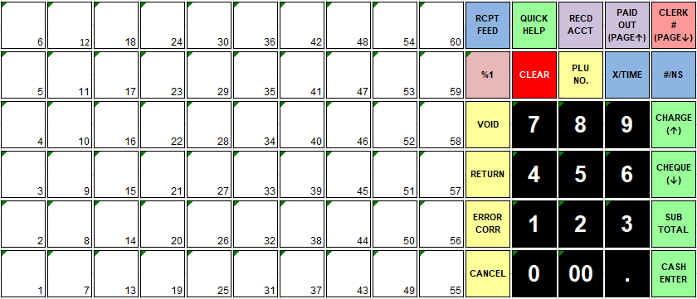

Please detail any specific requirements below (additional charges may apply):

Please enter your required delivery date

